***What you will need for the biotechnology course in English***

[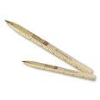](http://www.promotionslazaar.com/2/126.jpg)[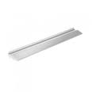](http://images.google.fr/imgres?imgurl=http://www.achateconomique.fr/2146-2230-large/regle-en-aluminium-avec-porte-stylo.jpg&imgrefurl=http://www.achateconomique.fr/2146-regle-en-aluminium-avec-porte-stylo.html&usg=__7YExBT8ax0_wHBUEz9f3vh-O8yg=&h=300&w=300&sz=6&hl=fr&start=4&um=1&itbs=1&tbnid=zDiyWGFBa8t16M:&tbnh=116&tbnw=116&prev=/images?q=stylo+r%C3%A8gle&um=1&hl=fr&sa=G&rlz=1T4GFRC_frFR211FR213&tbs=isch:1)[[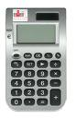](http://images.google.fr/imgres?imgurl=http://edengestion.fr/photos/calculette.gif&imgrefurl=http://edengestion.fr/calculette.php?menu=1&usg=__UaCSqyI9ZDjSS3Di2hvN-d2tuy4=&h=472&w=304&sz=66&hl=fr&start=9&um=1&itbs=1&tbnid=osbMZJD68UgOEM:&tbnh=129&tbnw=83&prev=/images?q=calculette&um=1&hl=fr&sa=G&rlz=1T4GFRC_frFR211FR213&tbs=isch:1)[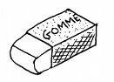](http://images.google.fr/imgres?imgurl=http://coloriage.mobi/images/gomme.gif&imgrefurl=http://coloriage.mobi/news/une-gomme&usg=__JU_HS4HKCIRnuVHbaOuBbotJFP0=&h=363&w=506&sz=5&hl=fr&start=1&um=1&itbs=1&tbnid=FEOePPUC21elKM:&tbnh=94&tbnw=131&prev=/images?q=gomme+%C3%A0+effacer&um=1&hl=fr&sa=G&rlz=1T4GFRC_frFR211FR213&tbs=isch:1)](http://images.google.fr/imgres?imgurl=http://coloriage.mobi/images/gomme.gif&imgrefurl=http://coloriage.mobi/news/une-gomme&usg=__JU_HS4HKCIRnuVHbaOuBbotJFP0=&h=363&w=506&sz=5&hl=fr&start=1&um=1&itbs=1&tbnid=FEOePPUC21elKM:&tbnh=94&tbnw=131&prev=/images%3Fq%3Dgomme%2B%25C3%25A0%2Beffacer%26um%3D1%26hl%3Dfr%26sa%3DG%26rlz%3D1T4GFRC_frFR211FR213%26tbs%3Disch:1)[](http://images.google.fr/imgres?imgurl=http://3.bp.blogspot.com/_Hg08Prhkbng/Sv05GJIvJdI/AAAAAAAABM0/gFx_cPnRpbY/s400/Tipex1.jpg&imgrefurl=http://annazoila.blogspot.com/2009/11/jag-ar-sa-retro.html&usg=__cejrmKnmDJhyFWzIvBGKncOO7eA=&h=340&w=340&sz=11&hl=fr&start=2&um=1&itbs=1&tbnid=7ghEQFMzAwz7dM:&tbnh=119&tbnw=119&prev=/images?q=tipex&um=1&hl=fr&sa=G&rlz=1T4GFRC_frFR211FR213&tbs=isch:1)[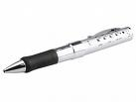](http://static.pcinpact.com/images/bd/news/30551-stylo-usb-mp3-brando.jpg)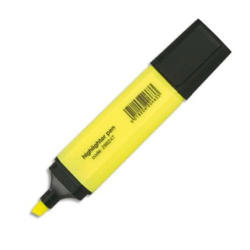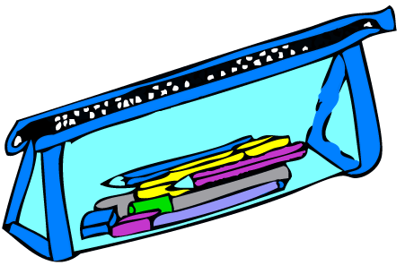

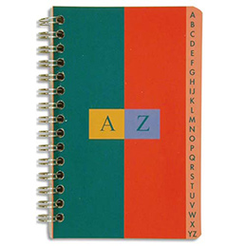

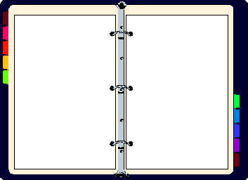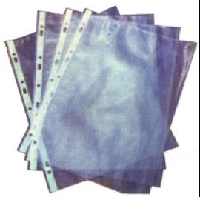

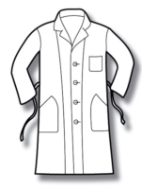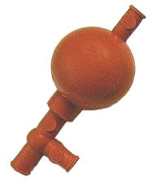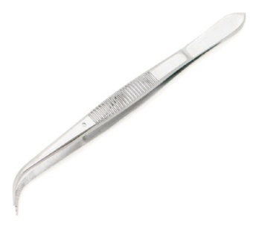

[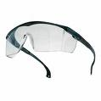](http://prymacontact.com/upload/photos/BOBLINE.jpg)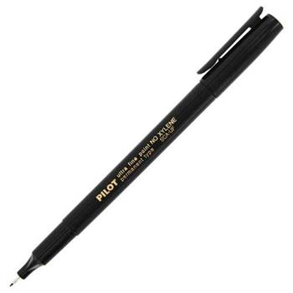

Schedule :

|  |  |  |
| --- | --- | --- |
| **Period 1** | **Period 2** | **Period 3** |
|  |  |  |