Course n° 5 : how to make bread

Lien avec l’enseignement de LV:
Vocabulaire spécifique (tsp…)
Compréhension orale
La séance 1 :

Activité | Temps | Activité prof | Activité élève | Document/support
Brainstorming on bread | 15 min |  | Describes the picture : men/woman, where, oven, crust/crumb, our bread compared to this… | Protocol: picture of bread baking in Mali
Making bread : video for overview | 10 min |  | Answers the questions
Translation of a bread recipe | 15 min | corrects | translates
Video how to make bread | 10 + 40 min | Reads the questions and explains if unclear; then projects the video | Listens and answers the questions

Pour la semaine prochaine : read the text presenting the role of leaveners and gluten.

La séance 2 :

Activité | Temps | Activité prof | Activité élève | Document/support
Sensory test on bread | 50 min | Explains the rules: 7 bread sorts, fill in the chart (exercise 5) | Make the test. Fill in a common chart on the white board: prefered bread  Taste the left bread with peanut butter, lemon curd. | Documents for course 5

In the notebook : specific terms corresponding to course n°5
For next time: webquest on the feisty creatures in bread.

Course n° 5 : How to make bread…

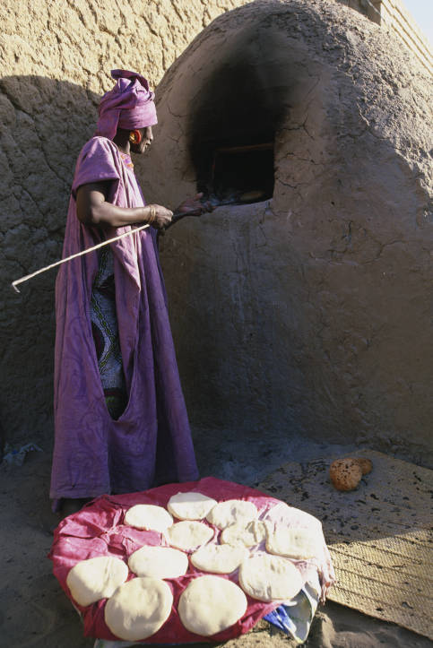

- Getting an overview
Log onto the following site:
http://www.youtube.com/watch?v=bHK0uFb6Vzw

Watch this video and answer following questions:
- Tell why it is interesting to eat wholemeal bread (= (brit.) pain complet):

- Make a list of the ingredients you can see:

- Make a list of the steps involved in making bread as seen in the video:

- The recipe

To increase our knowledge we are going to watch a second video:
http://www.youtube.com/watch?v=zOa-U6uFHoU

  - Here is the recipe used in the video. Translate it.

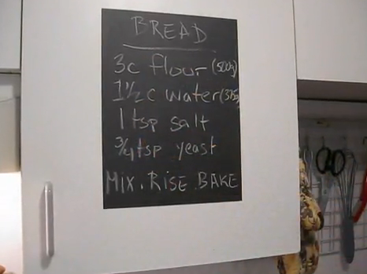

  - Read the following questions carefully and try to answer them while watching the video. The following sign corresponds to a pause in the projection of the video: .

- If dry yeast is not made out of little grains what should you do before use:

- Should you use a spatula or a maryse to mix the ingredients (say mariise or rubber spatula):

- Until when should you mix:

- Give two adjectives to describe the bread dough obtained:

2:47

4:43

- What will happen now?

- What do you sprinkle over the risen dough and on the work-top:

- What does yeast transform sugar into?

- What happens to the alcohol during the baking?
6:46

- Sensory test

Your teacher will provide you with 7 different breads. Taste each one and fill in the following table, except line n°2, using plus signs (according to your preference from one up to three).

Sample n° | 1 | 2 | 3 | 4 | 5 | 6 | 7
Bread category
General aspect
Smell
Crust
Crumb
Taste
Score

Try now to fill in line n°2 using the following bread categories:
White, brown, wholemeal, whole-grain, unleavened, sourdough, flat bread.

Mention which bread was the most popular in the class:

Make a comment on this result:

